Synopsis: Gympik is a going to be a market place where the health practitioners can register themselves and user should be able to search them.

Modules:

**User registration :()**

a. Registration for trainers, dieticians

b. registration for the users something similar to this

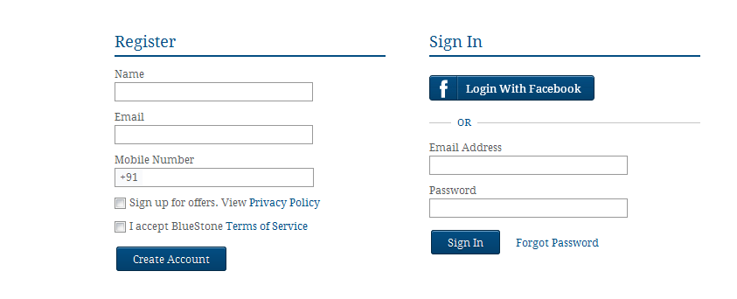

**Trainer registration:**

From the home page trainer should be able to click on registration page where he/she would need to register the personal, contact details and primary & secondary skills. The primary and secondary skills would be a drop down values from db (eg. Physical Trainer, Nutritionist/Dietician, Physiotherapist, Yoga Instructor, Aerobics, Martial Arts)

There would also be an option for trainers to specify (typical checkbox) if they are ready to take a group activity. (to store the preference for individual instructor)

Account activation via email following welcome mail with FAQ’s.

The landing page for trainer would be a dashboard (similar to user one) where trainer would be able to see the list of users under. After selecting an individual user we can use a multi tab layout to showcase the details of user workout/progress etc and a provision for trainer to input workout schedule, meal suggestion etc.

The header and footer menus (one in homepage) should be same for trainer.

Instead of sign-in and registration, sign-out and edit profile

**Search for a trainer**

) Find your Trainer- This should be a pop-up focussed implementation i.e. when user clicks on the “Find Your Trainer” there should be a new rectangular box comes up on top of the current shaded page. In order to cancel the search user can press escape or close. I have seen this implementation mainly for notifications. Eg.

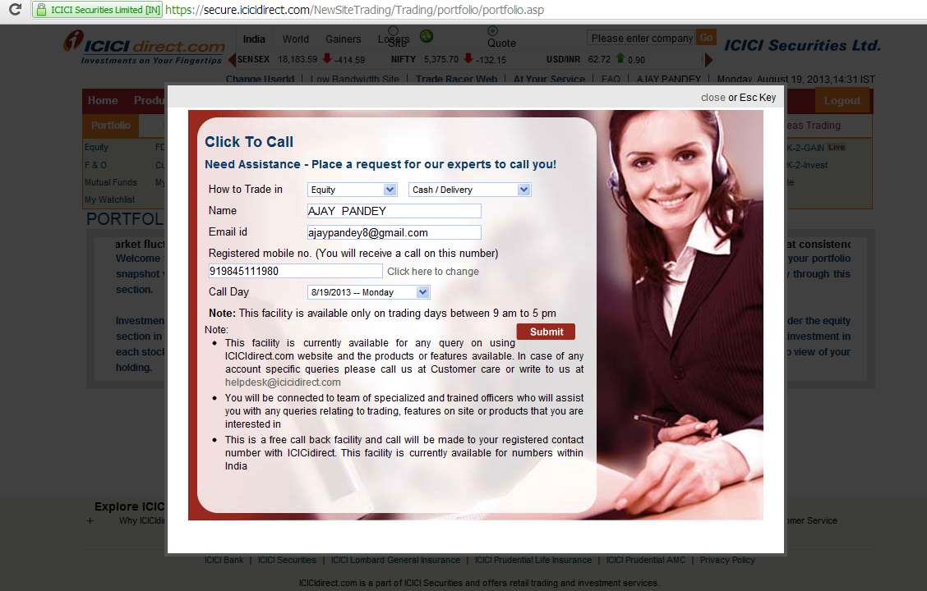

The pop-up would ask series of questions from user for a trainer search. The flow with the fields below:

a) Address: City, Locality, Pincode, Trainer type (dropdown to select which trainer i.e. physical trainer, yoga teacher etc)

b) Trainer preference: Male / Female, How often you need a trainer- (this will be a drop down values- everyday, 3 days a week, 4 times a month), Do you need a dietician consult- Yes or no.

The results would be displayed only in user has logged-in. In case if user lands from homepage then should get prompted for either sign-in or register. ( refer to fitorbit find trainer search)

**Home Page of the trainer:**

The trainer will have all the details about his clients and he should be able to set the workouts and diet for them.

**User home page:**

The dashboard would be the home page after user logs-in. Dashboard title- “Fitness Dashboard”

Dashboard would have multiple tabs/links to left side (with a small respective pic for each tab pan) and respective info on right( like tab-pans) for user to view/add data like current measurements, target goal, daily intakes, etc.

Tabs details:-

1) Daily workout schedule- This will be a typical work schedule where user will have a provision to select from dropdown if a particular exercise is completed or not. The workout schedule would fetch from db which either be created by trainer or by admin or by user itself.

For each exercise there will be details display for example Cardio- running, speed, incline, distance, level etc.

Below the exercise schedule user would have an option to enter footnotes and see any notes enter by trainer

On the right side top corner of the tab pan there will be a module showing the graphical progress of user daily calorie burn i.e. Once user acknowledge a particular workout completed the no. of calories would be added in the days graph.

Below the graph user would have a provision for creating/adding workouts for a day or week schedule. For addition user should get a focussed pop-up implementation to select predefined workouts.There is no option for user to add any custom workouts.

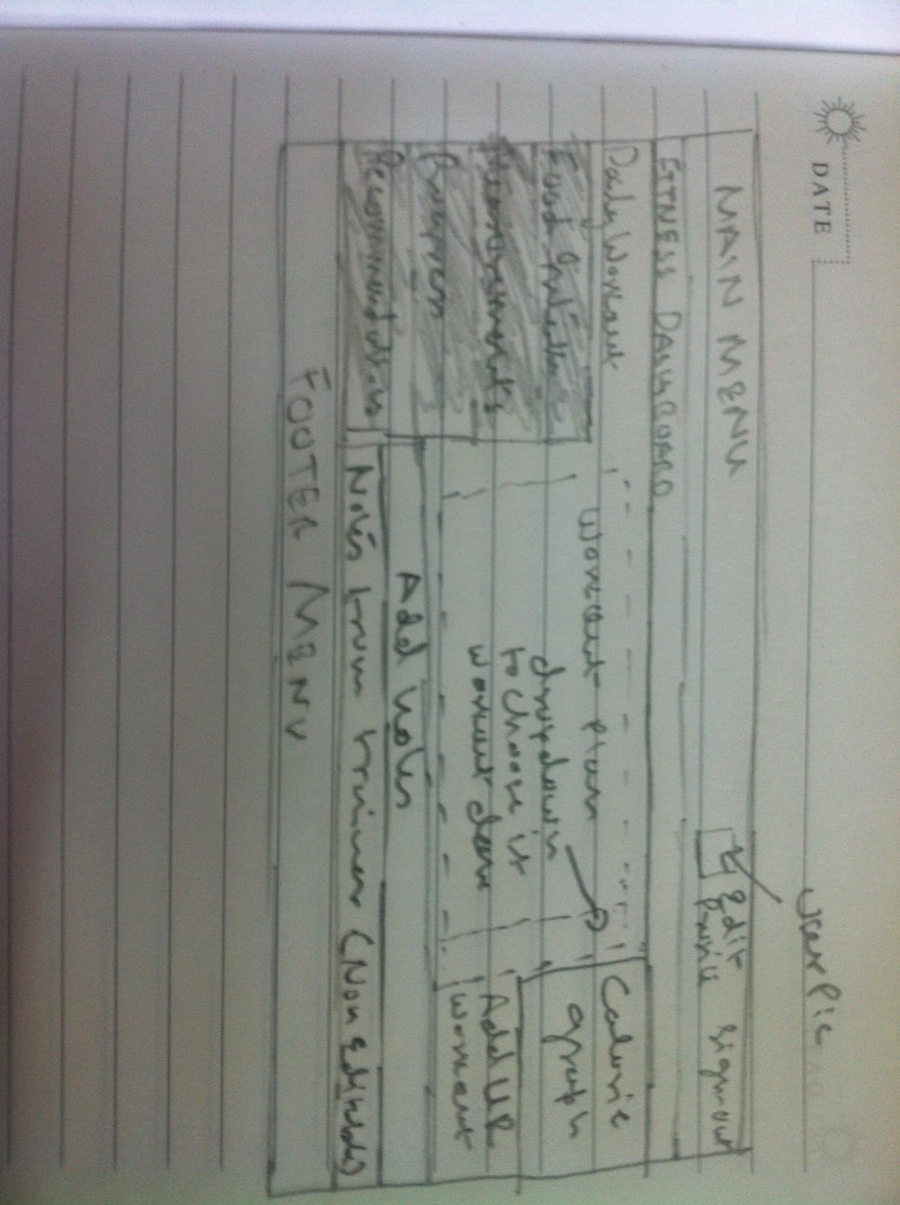

2) Calories Intake- On this tab user can enter daily meals/anything consumed and track the calories intake.

To start on this tab there will be a text box asking “What did you eat today” (this is not a lable but in the text box. Soon user clicks on the box this disappears. There will be “Add Food” button to add the food entry in a daily log. While user types he/she should get relevant suggestion list (like google search)

Below the box user would have a provision to select a serving size and meal type (dropdown for breakfast, lunch, dinner or snacks)

On the right of the text box (above two) there will be a rectangular box with 3 subtabs- Food Journal, Recent and Custom. Idea is to provide an option to user to select entry from categorised list. From the recent tab user can quickly select any entry which he/she might have choose in last one week and Custom tab will list all the custom meals added by user.

The above layout would take 2/3rd of the tab. The rest 1/3rd on the right side would display the calories intake graph and an option for user to add custom meal, which would be a focussed pop-up to take entries.

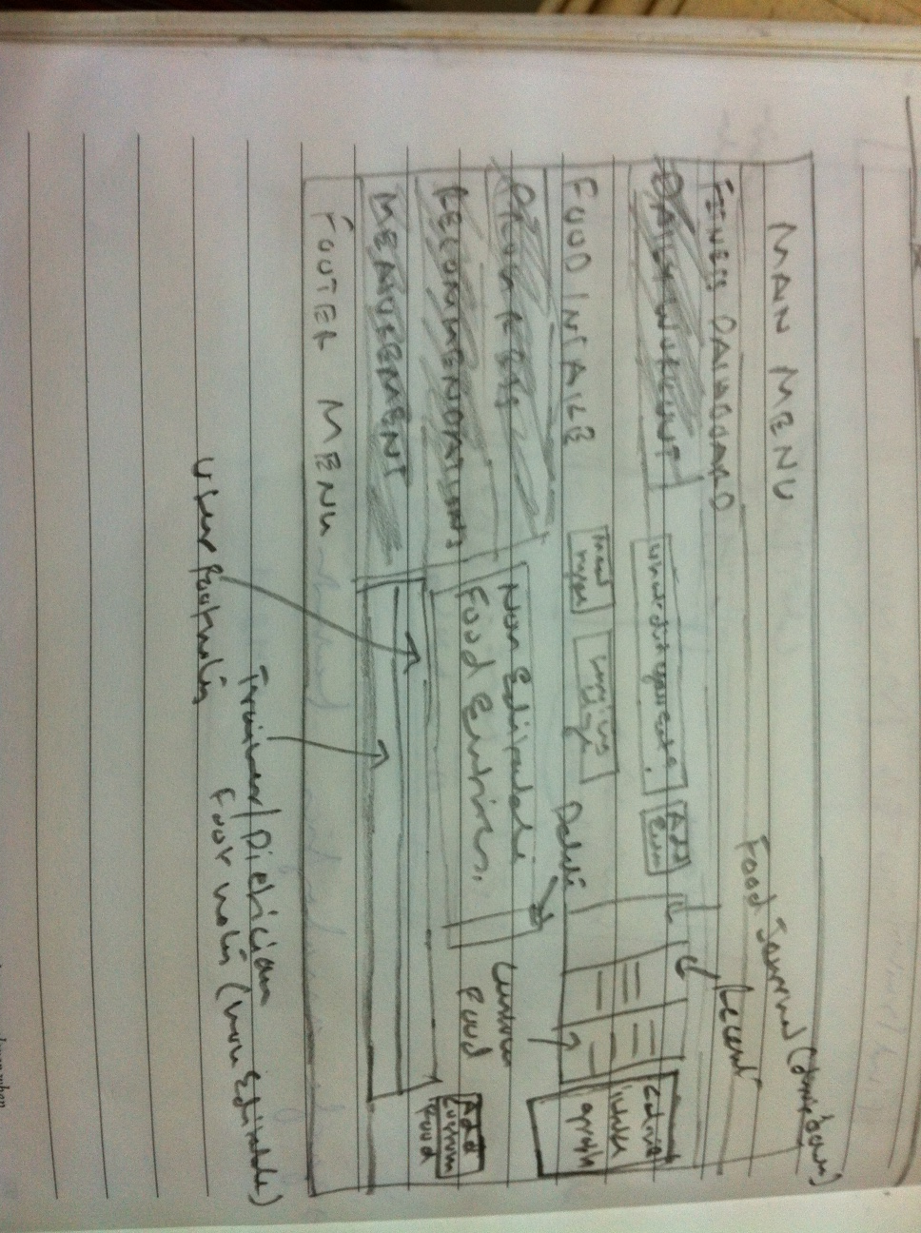

On the footer of the tab, user would have an option to enter footnotes and see any notes enter by trainer/dietician.

3) Progress- On this tab there will be a linear graph (weekly) showing calories consumed vs calories burned. User will have a provision to select duration in week, 2 weeks, 3 weeks, month, 2 months, 3 months, 6 months, 9 months, 12 months

On the right on the rectangular graph (above) there will be drop down for user to select. By default its calorie graph. User can select values like measurements, calorie intake, calories burned, etc. (the drop down is populated from db and depends on the choice the data get shown in the graph)

Below dropdown there will be monthly calendar for user to select particular day to see the progress.

4) This tab will have 4-6 rectangular modules containing either articles or tips for individual users. Each module will have a heading, an image and few lines with readmore hyperlink. The data should get populated from DB. Admin would set this for each user for now. For future there is a plan to write an algo considering user data + other inputs for recommendations.

5) Measurements- This tab will enable users to enter measurement and record the same in db. There will be a dropdown for measurement types eg. Weight, Body Compositions, Body measurement etc. and plain text fields to enter values.

For weight there will be only one text field and other dropdown for a scale i.e. either in pounds or in kgs

For Body Composition- Body type, Height, Weight, BMI, BMR (2 fields for KJ and kcal), Impedence, Fat%, Fat mass, FFM and TBW

Body Measurement- Neck, Bicep, Forearm, Chest, waist, Hips, Thigh and Calf

For future any other dropdown it should read the respective text fields from db.

On the right side there will be a simple linear graph showing weight measurements against timelines. There will be a dropdown which will enable user to choose the measurement types and the graph will show the respective values.

Below there will be a linear graph showing the recommended per week progress for the required goal to achieve. The goal user would have to create after 3 logins or anytime before.

The first tab on dashboard would list the workout plan for user to follow. Work out plan would be updated weekly i.e. at a given point of time user can only see a week long workout plan.

Work out details would be non-editable tab. The details would be added by either a trainer or admin. (Though user should be able to acknowledge the completion of the workout planned)

There would also be a reporting/status tracking tab to showcase the progress via liner/bar graphs and pie charts.

There would also be a provision for user to search for a trainer based on asked preferences and location. After search result display user should be able to check individual trainers profile and request for a notification. There should also be a provision for a user to enter few lines of text as a plain message for trainer.

Once user click on notification for a trainer there should be an automated email to trainer cc to admin with user’s msg.

The header and footer menus (one in homepage) should be same for user.

Instead of sign-in and registration, sign-out and edit profile

Horizotal extreme right to Dashboard title we will have “Find Your Trainer” link. When user clicks on this link after login it will follow the same steps mentioned below (when user clicks from home page). At the end the results would be displayed in a new page which will list the trainer image, name, his/her speciality and few words about trainer with readmore hyperlink to detail trainer profile page. Layout of this page:

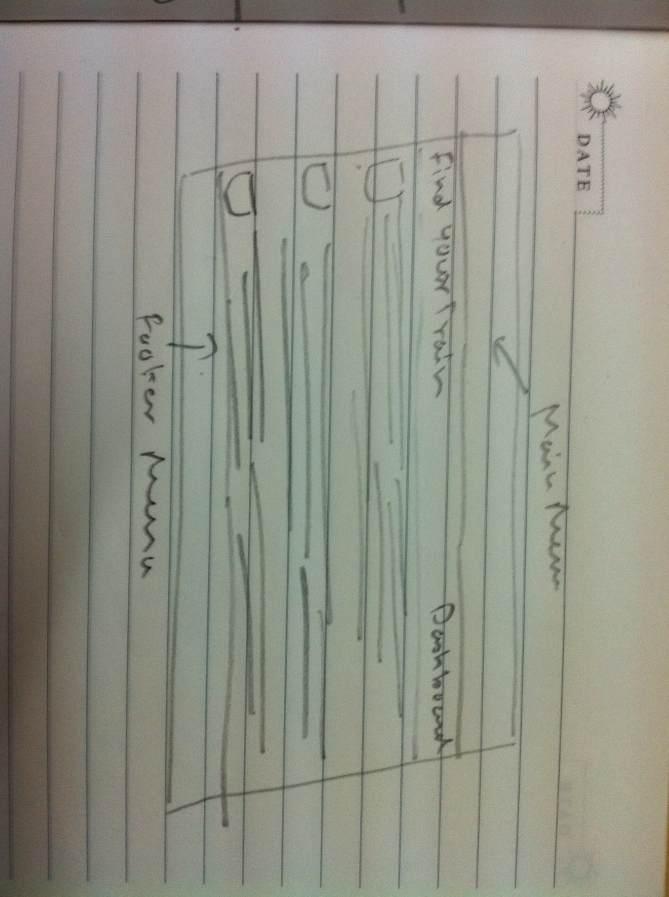

If user clicks on “Dashboard” he/she will return to dashboard page.